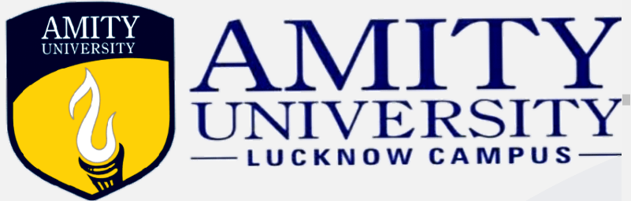
NATIONAL SEMINAR

on
Right to Privacy and Data Protection in Digital Era - Issues & Challenges

“Right to privacy of any individual is a natural which inheres in every human being by birth. Such right stays with the human being till he/she breathes last. It is indeed inseparable and inalienable from human being. In other words, it is born with the human being and extinguished with human being,"
- Justice Abhay Manohar Sapre
Concept Note

We are living in the era of technology and with the emergence of technology, the privacy of the individual is at risk. Human beings have a need to control certain aspects of their lives. The conceptualization of the state under The Constitution of India is based on two folds: First, the state is a facilitator of human progress. Consequently, it is commanded by Part IV of The Constitution of India that includes, to serve the common good and the state is prone to excess.
This conceptualization as set forth by the Holy Constitution of India is engineered by effectuating the federal structure as well as the three organs of government, consequently investing every individual with fundamental rights that can be enforced against the state.

The Arthashastra prohibits entry into another’s house, without the owner’s consent, The Hadith makes it reprehensible to read the correspondence between others and in Christianity, we find the aspiration to live without interfering in the affairs of others. Religious and social customs affirming privacy also find acceptance in our laws, for instance, in the Civil Procedure Code there is exemption given to a pardanashin lady regarding her appearance in Court.
In the landmark judgement of Justice K.S. Puttaswamy (Retd.) vs. Union of India, the right to privacy was recognised as a fundamental right essentially originating from Article 21 of the Indian Constitution. To Make this right impactful, the state must establish a data security system that fosters the common good while protecting the citizens from potential attacks to privacy and confidentiality posed by both state and non-state entities. Hence, establishing the fact that a person’s privacy is a crucial aspect of their life and liberty, and therefore, it must be respected and preserved.
The right to privacy is stipulated in the Universal Declaration of Human Rights, the International Covenants on Civil and Political Rights, and the Convention on the Rights of the Child. In India, this prerogative has been recognized as an intrinsic element of the right to life and liberty, along with the right to freedom of speech and expression.
Every person is eligible for a ‘personal domain’ free from unjustified interference or surveillance by the State or non-state actors. Notwithstanding the pervasive recognition of the obligation to protect privacy, the specific content of this right is yet not fully developed by international human rights protection mechanisms. Living in a modern civilization and a global network so huge in magnitude, we are being profiled in our day-to-day life. We live in the digital era, where we embrace the need to provide intimate details concerning ourselves to appropriate authorities, expecting that they will maintain this information private and only use it in the most egregious circumstances with legal justifications. On the contrary, there is no concrete and comprehensive legislation to mitigate the issue arising out of internet privacy and data protection. Privacy is not always absolute and comes with certain constraints. Multiple laws have been enacted by the concerned State authorities to preserve the privacy of their data subjects, however these safeguards are not absolute and are limited in certain areas by the government. However, as more data is digitised and information is transmitted online, the right to privacy and data protection is becoming more crucial. People have a lot at forefront when it comes to the confidentiality of their information, therefore data must be governed based on its perceived importance. As a result, there is a need for protection of such information that users are unwilling to provide and, if shared, must be safeguarded. It necessitates adequate state and legislative intervention to ensure that people's privacy is protected and to establish the amount to which it must be invaded. Hence, this seminar provides a premier interdisciplinary platform for researchers, practitioners, and educators to present and discuss the most recent innovations, trends, and concerns as well as practical challenges encountered, and solutions adopted in the field of right to privacy.

WHO CAN PARTICIPATE?
- Law Students / Students interested in any interdisciplinary field
- Research scholars from Law / IT and any other interdisciplinary field
- Academicians from various fields
- Professionals (Legal / IT Professionals and other interdisciplinary field
THEMES
Session: 1 - Tracing Right to Privacy: Emergence & Evolution
- Concept of Right to privacy
- Indic Jurisprudence of Privacy
- Constitutional Perspective of Right to Privacy
- Judicial Interpretation of Right to Privacy and Data Protection in India
- Comparative Analysis and International Trends in Data Protection
Session: 2 - Liability of Data Protection: State & Non–State Actors
- Liability of Intermediary
- State Surveillance as a threat to Right to Privacy in Cyberspace
- Non-Sate actors in violation of the Right to Privacy
- International Efforts to Protect Privacy
Session : 3 – Emerging Cybercrimes : Socio - Economic perspective
- Cyber frauds and its impact on the Indian Economy
- Revenge Pornography
- Online Grooming
- Cyberspace and Interpersonal Relationships
Session: 4- Recent Trends and Challenges
- Ransomware
- Data Mining
- Phishing & Other Social Engineering attacks
GUIDELINES FOR PAPER SUBMISSION
The title of the paper should be followed by:
- Name,
- Designation,
- Name of the Organization / University / Institution and
- Email address.
It is mandatory to mention the E-mail address, as all future correspondence will be through it.
Name and contact information of co-authors, if any.
PROCEDURE FOR SUBMISSION OF ABSTRACTS:
- The abstract should not exceed 250 words, containing 5 relevant keywords.
- The following information, in the given format, should be sent along with the Abstract: Name of the Participant, Official Designation/Institution Details, Address and Email id, Title of Abstract, should be sent along with the Abstract in the given format.
- Submit your abstract to nationalseminaramitylko@gmail.com
Note: Last Date for Abstract Submissions – 20th January 2023.

FULL PAPER:
- Abstract & Full Paper will submit as a soft copy only in MS Word format (typed in Times New Roman, 14-point Heading and 12-point normal text with 1.5 spacing & 10 points with 1.0 spacing for footnotes).
- Citation Format: Please use footnotes rather than endnotes. Footnotes should conform to The Indian Law Institute, New Delhi Style.
- Submission of the abstract: A cover letter with the name(s) of the author(s) and address, designation, institution/affiliation, the title of the manuscript and contact information (email, phone, etc.) is compulsory to submit.
- The title of the Paper will be followed by Name, Designation, Name of the Organization / University / Institution and Email address. It is mandatory to mention the E-mail address, as all future correspondence will be through it; Name and details of the Co-author, if any.
- In case the paper gets selected for publication in a book containing ISBN No. of conference proceedings or Journal with special issue having ISSN number, the author will have to send a signed declaration waiving the copyright and stating that all the submissions made are original and bona fide work of the author.
- The length of the paper should not exceed more than 5,000 words.

CERTIFICATE FOR PARTICIPANTS:
- Certificate of Participation will be issued to all the participants as well as those who have given their abstracts with the required fee.
REGISTRATION FEE:
- Professionals/ Faculty- Rs. 1500
- Research Scholars- Rs.1200
- Students outside Amity -Rs.1000
- Amity Students – Rs.800
FOR REGISTRATION AND PAYMENT
- https://www.amity.edu/lucknow/paymentgateway/rpdc2023

IMPORTANT DATES:
- Last date for registration & submission of Abstract – 20th January 2023
- Confirmation of Abstract selection – 25th January 2023
- Submission of Paper in proposed form – 5th February 2023
- Seminar Date – 16th & 17th February 2023
ACCOMMODATION & TRAVEL
- Accommodation will be provided on a first come first serve basis
- Travel allowance will not be provided to any of the participants.
ABOUT:
AMITY UNIVERSITY UTTAR PRADESH, LUCKNOW CAMPUS
Amity University Lucknow Campus (AULC) is a constituent unit of Amity University, Uttar Pradesh & it was established in the year 2004 with the sole aim to impart research & innovation-driven education in the region.
The 40-acre state-of-the-art campus is a fine blend of global education, training & research within an academic ambience. With the latest teaching methodologies, AULC offers UGC-recognized Undergraduate & Postgraduate courses in multiple disciplines.
It has 17 institutions which cater to 87 programs having more than 5000 students. The multiple research centers at AULC felicitate research in diversified areas like Nanotechnology, Biotechnology, Electronics, Agriculture, Forensic Sciences & many others.
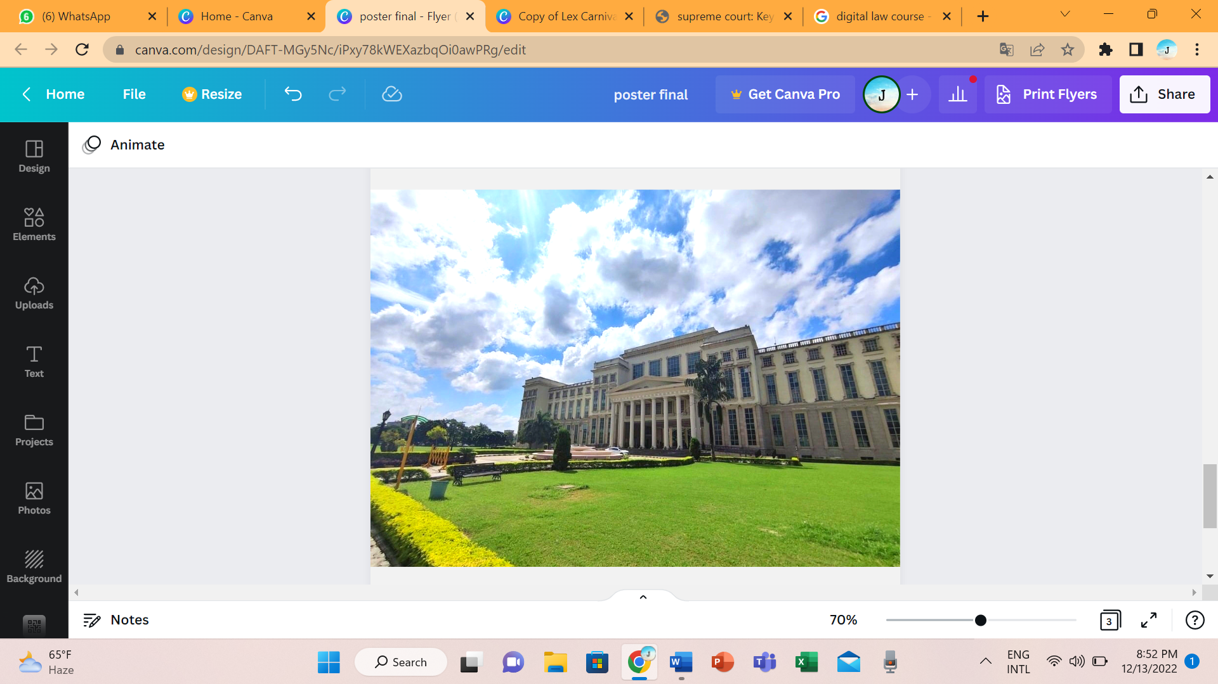

AMITY LAW SCHOOL, LUCKNOW
Amity Law School Lucknow Campus (ALS-L) is a constituent unit of Amity University, Uttar Pradesh & it was established in the year 2007 with the sole objective to impart research & innovation-driven education in the region. ALS is a fine blend of global education, training & research within an academic ambience. With the latest teaching methodologies, offers UGC-recognized Undergraduate & Postgraduate courses in the law discipline. ALS-L has taken major strides in enhancing internationalization on campus. The intent is to create a multicultural environment that facilitates a truly international and collaborative learning process. With more than thirteen hundred odd students in UG and PG level programs, Amity Law School, Lucknow Campus has instituted the Mentor-Mentee Program to help students to make the right career choice and overcome all hindrances to a successful career. Through this program, students are assisted by faculty in their time of need. The extremely low student-teacher ratio ensures that each faculty member has a group of students under them whom they can guide through regular career counselling, just like a true mentor.
Amity Law School of Amity University Lucknow Campus is currently headed by Prof. (Dr.) J.P. Yadav. The Law School has successfully organised various events from time to time around the year like International and National Seminars, Law Fests and Carnivals, Workshops, National Quizzes, National & Intra Moot Court Competition and National Faculty Development Programmes to name a few.

The intellectual trends of ALS-L are reflected in the programs offered by it, some of it includes:
- Regular visits to High Court, District Court, Tribunals and Central Jails
- Moot Court Competitions, Legal Quiz, Seminars, and Legal Aid Camps
- Regular Interaction with distinguished lawyers, judges & Jurists
- Summer Internship and training programs to work under experts in reputed Law firms, Legal Aid Clinics to get hands-on experience related to various legal issues faced by the local community
- Senior Lawyers, and Corporate Houses.
- Tips by experts on Judicial Exams and preparation through Mock Tests. Many of our students are working in Delhi Judicial Services, Rajasthan Judicial Services, Bihar Judicial Services, and other government organizations.
- New-age courses like Artificial Intelligence (AI) as part of the curriculum.

Our Law students undergo training and projects besides activities like:
- Guest Lectures
- Summer Internship
- Technical skills enhancement programs
- Seminars & Workshops
- Moot courts
- Mock Session

Courses offered by ALS-L:
- B.A. LL. B. (Hons)
- B.Com. LL.B. (Hons)
- BBA LL.B. (Hons)
- LL.B.
- LL.M.
- Doctor of Philosophy (Law)
- Doctor of Philosophy (Law) - Part Time

PATRON IN CHIEF
HON’BLE DR. ASHOK K. CHAUHAN
Founder President RBEF
Amity University

CO-PATRON IN CHIEF
HON’BLE DR. ASEEM CHAUHAN
Chancellor, Amity University
Additional President, RBEF
CEO, Amity Capital Ventures

PATRON

PROF. (DR.) BALVINDER SHUKLA
Vice Chancellor
Amity University, Noida

WG. CDR. (DR.) ANIL KUMAR (RETD)
Deputy Pro Vice Chancellor &
Director, ASET
Amity University Uttar Pradesh
Lucknow Campus

CHAIRPERSON OF THE EVENT
PROF. (DR.) J.P. YADAV
Director
Amity Law School
Amity University Uttar Pradesh
Lucknow Campus

FACULTY CONVENER
- Dr. Rajeev Kumar Singh (9026480959)
- Dr. Shashya Mishra (9454362378)
CORE COMMITTEE
- Dr. Reshma Umair (7376100972)
- Dr. Anuj Kumar Sharma (9415543356)
- Dr. Taru Mishra (9918777709)
- Ms. Priyanka Srivastava (7880359777)
- Dr. Amarendra Kumar Srivastava (9450616533)
- Ms. Sarita Yadav (8953282526)
- Mr. Abhishek Anand (7905061606)
STUDENT CONVENERS
- Versha Singh (8739086379)
- Jasmine Suri (9415160990)
STUDENT CO-CONVENERS
- Rituporna Das (7417467976)
- Yash Krishna Pandey (7007404195)
STUDENT ORGANISING SECRETARY
- Rishi Raaj (9044365694)

CONTACT INFORMATION
For any information contact: nationalseminaramitylko@gmail.com

